COURSE CODE/TITLE: | CPE010 – Data Structure |  | SECTION: | CPE21S2
DATE PERFORMED: | July 22, 2026 |  | DATE SUBMITTED: | July 29, 2026
NAME: | Macatangay Justin Jake B. |  | INSTRUCTOR: | Engr. Jimlord Quejado

ACTIVITY NO. 3.1 | [ACTIVITY NAME]
1. PROCEDURE OUTPUT
Table 3-1. Output of Initial/Simple Implementation
Operation | Screenshot
Traversal | 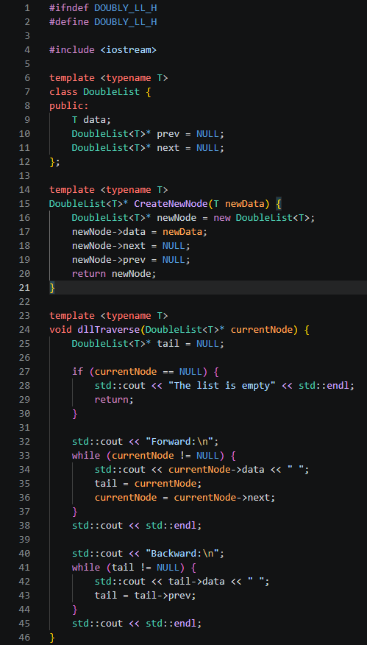
Insertion at head | 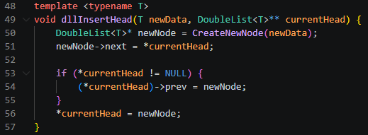
Insertion at any part of the list | 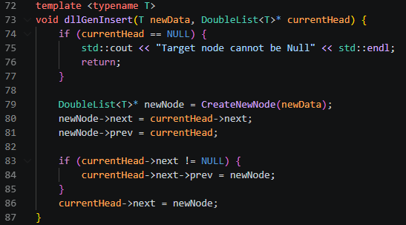
Insertion at the end | 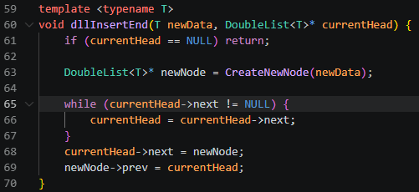

Deletion of a node | 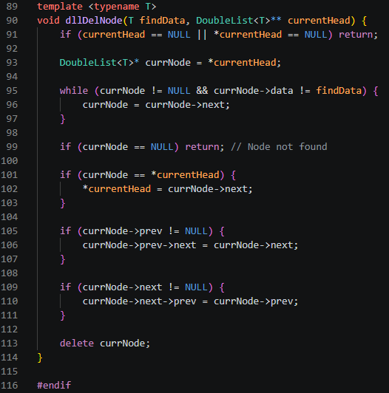
Table 3-2. Code for the List Operations

a | Source Code | 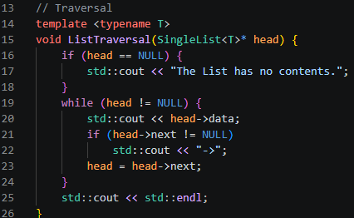
a | Console | 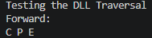
b | Source Code | 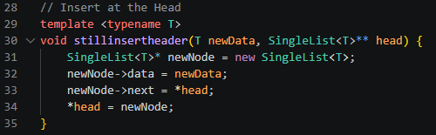
b | Console | 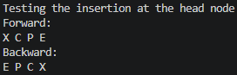
c | Source Code | 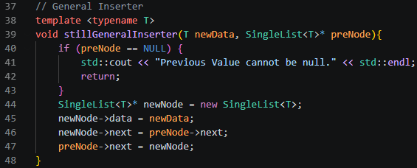
c | Console | 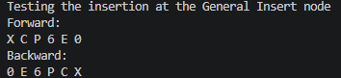
d | Source Code | 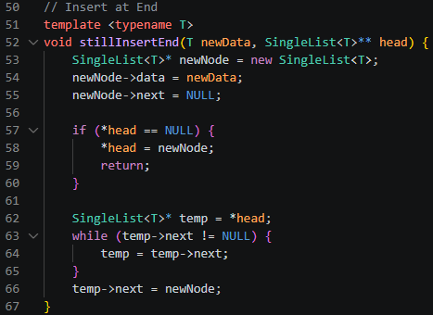
d | Console | 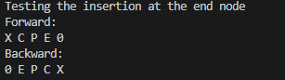
e | Source Code | 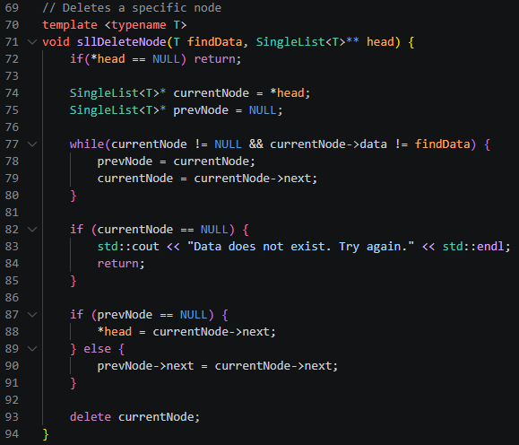
e | Console | 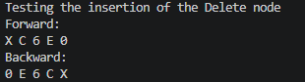
f | Source Code | 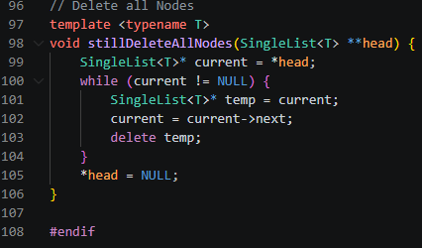
f | Console
Table 3-3. Code and Analysis for Singly Linked Lists
Screenshots(s) | Analysis
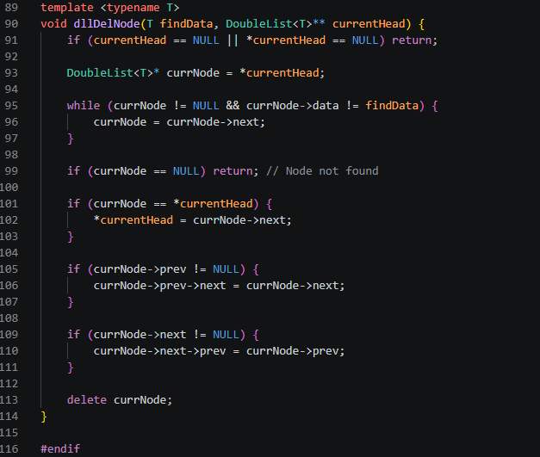 | The dllDelNode function deletes a specific node by value from a doubly linked list while properly maintaining pointer connections. It starts with safety guards to ensure the list is non-empty, then traverses the list to find the matching findData. Once found, it handles pointer reassignments: if the target is the head node, it updates *currentHead to the next node; if a previous or next node exists, it updates their next and prev pointers respectively to bypass the target. Finally, it calls delete currNode to free the allocated memory and prevent memory leaks.
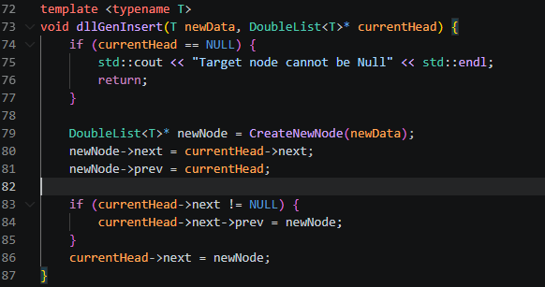 | he dllGenInsert function inserts a new node into a doubly linked list immediately after a specified target node (currentHead). It first checks if the target node is NULL to prevent invalid memory access. After allocating newNode, it sets the new node's next and prev pointers to bridge between the target node and the subsequent node. If a subsequent node exists (currentHead->next != NULL), its prev pointer is updated to point back to newNode. Finally, it updates currentHead->next to point to the new node, successfully splicing it into the list.

2. ANSWERS TO SUPPLEMENTAL ACTIVITY
Copy and paste the questions from the lab and include your answers after.
CODE | OUTPUT
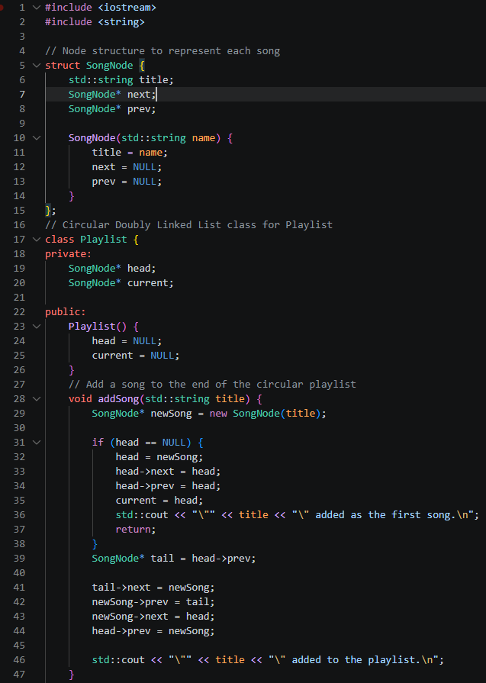  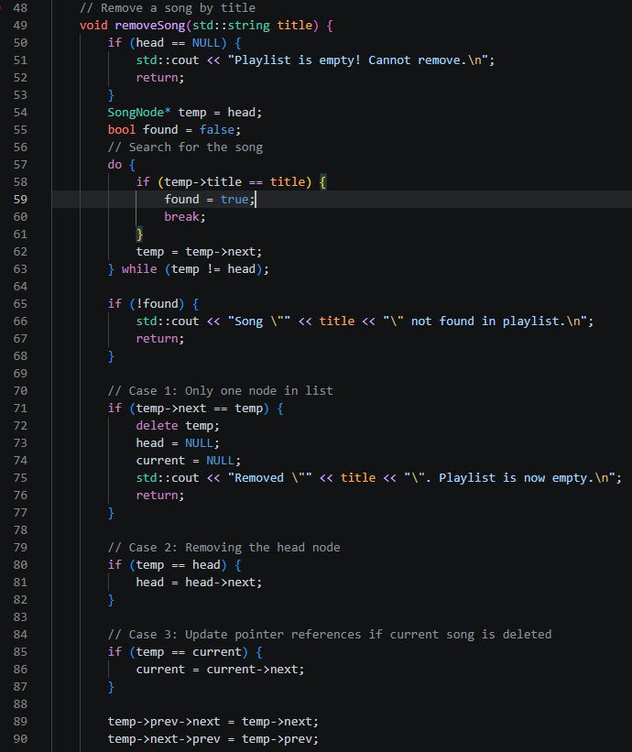  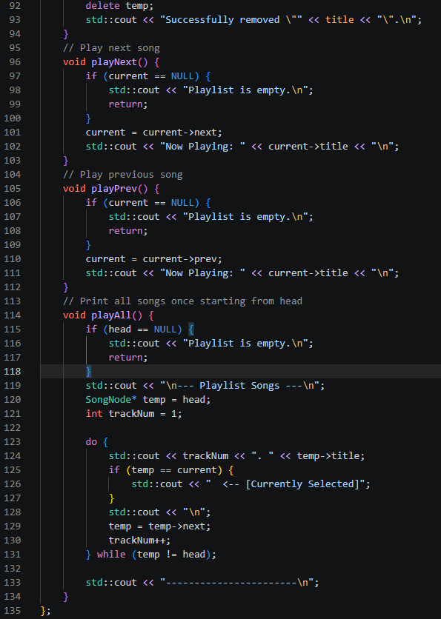  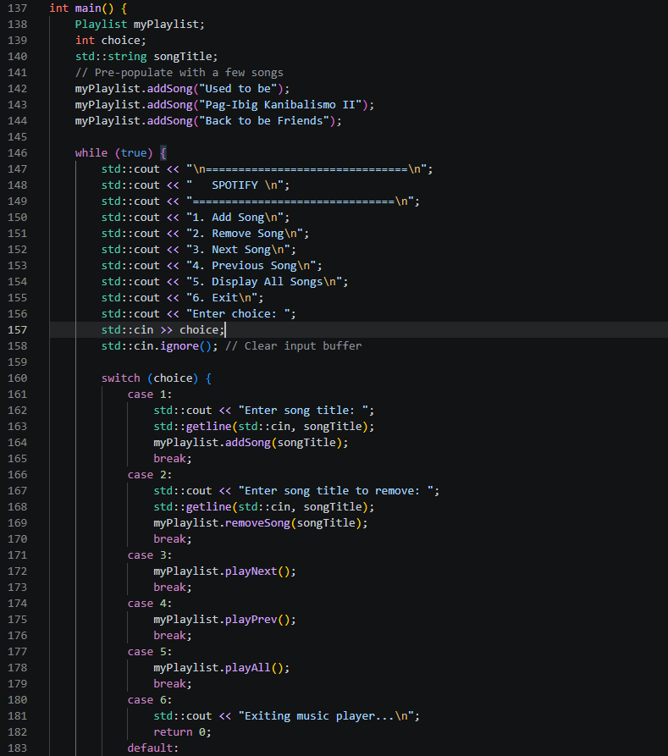  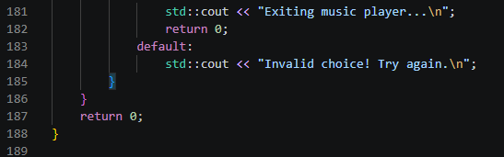 | 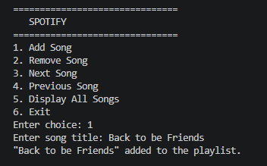  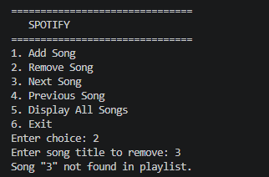  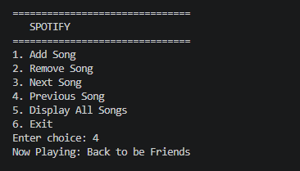  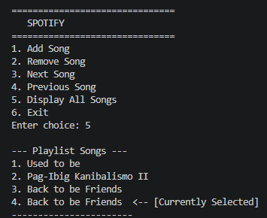  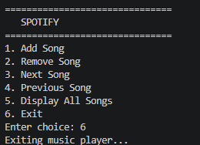

Conclusion
Through this activity, I learned that linked lists work like a chain where each node is connected to the next one, making it easier to insert or remove data without changing the whole structure. which helped me understand why every link between nodes is important.
3. ARTIFICIAL INTELLIGENCE (AI) USE DISCLOSURE STATEMENT
I hereby declare that artificial intelligence (AI) tools were used, if applicable, in the preparation of this academic work. The following indicates the nature and extent of AI assistance:

Tools Used:
Examples: ChatGPT, Microsoft Copilot, Grammarly, QuillBot, etc.

Purpose of Use:
Examples: grammar correction, idea generation, formatting, summarization, code assistance, explanation of concepts, etc.

Extent of Use:
Explain how AI was used and confirm that it did not replace original thinking, analysis, authorship, or completion of the required work.

By submitting this activity, I affirm that my use of AI complies with T.I.P.’s AI usage policy and does not exceed the permitted limits for similarity, automated content generation, or academic assistance.

I understand that any false, incomplete, or misleading disclosure may be subject to investigation in accordance with due process and may result in sanctions for violation of existing T.I.P. policies.

Lab activities, templates, and related instructional materials shall not be reuploaded, reproduced, distributed, or shared with external organizations or third parties without the prior express written permission of the Technological Institute of the Philippines.

